**MICRO-DEGREE INTERNSHIP**

**NAME:BHAVITH KUMAR B C**

**USN:4SN23MC009**

**PROJECT-1-DEPLOYING A WEBSITE ON AWS EC2 INSTANCE**

Virtual private cloud :

Steps : 1. In AWS console, search VPC.

2. In VPC dashboard , you will get my VPC’s and click on myvpc’s.

3. Click on create VPC. Select resource to create as vpc only.

4. Give name as -vpc and IPv4 CIDR as 10.0.0.0/16.

5. Then click on create VPC.

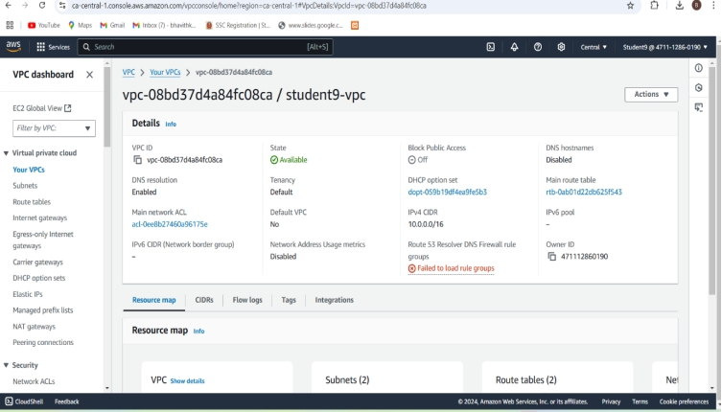

**Public Subnet 1:**

Steps : 1. To create subnet, go to VPC dashboard under virtual private cloud, click on subnet.

2. Select the vpc you have already created and in subnet setting, give subnet name as public-subnet-01 .

3. Then choose availability zone as region you have selected before creating the vpc and IPv4 subnet CIDR block as 10.0.1.0/24.

4. Then create one more subnet as following subnet but give name as public subnet-02 and then choose availability zone and IPv4 subnet CIDR block as 10.0.2.0/24.

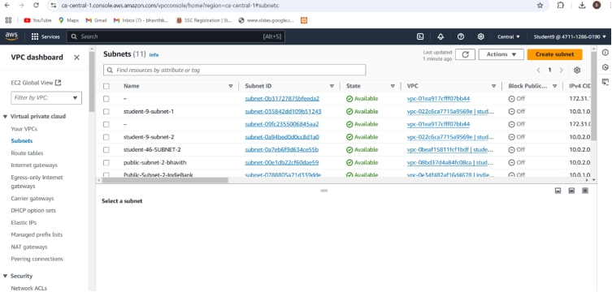

Router Table :

Steps : 1. To create Route table, click on create route table.

2. In route table setting, give route table name as anu-route-table-01 and select vpc that is created.

3. Then click on create route table.

4. After route table is created, go to routes and click on edit route and then click on add route.

5. Then in destination, select 0.0.0.0/0 as destination and target as Internet Gateways .

6. After selecting internet gateway, it allows to select the igw- and select the internet gateway that is created by you.

7. At last click on save changes.

8. Then go to subnet association and click on edit subnet association.

9. Select the subnet you have created and click on save changes.

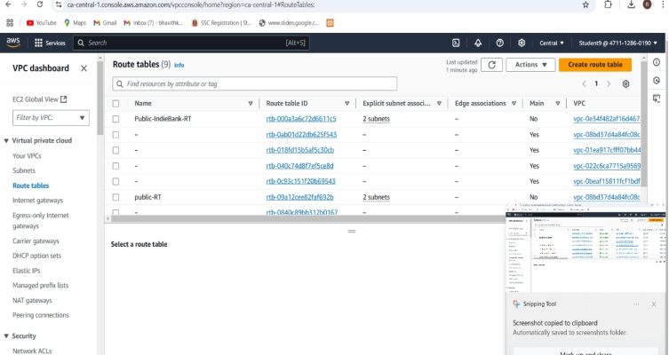

**Internet Gateway:**

Steps : 1. In VPC dashboard, click on Internet Gateway.

2. To create Internet gateway, click on create Internet Gateway.

3. Then give name as Anu-igw and click on create Internet Gateway.

4. Your internet Gateway is created.

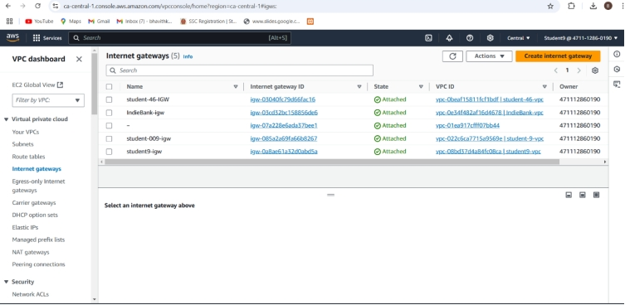

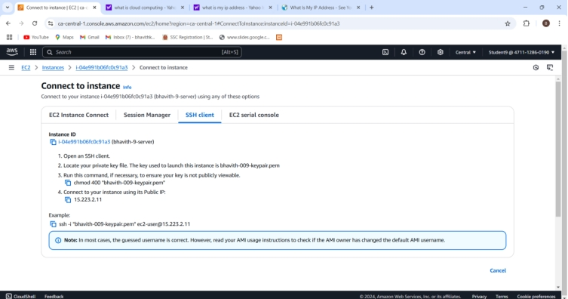

Connections

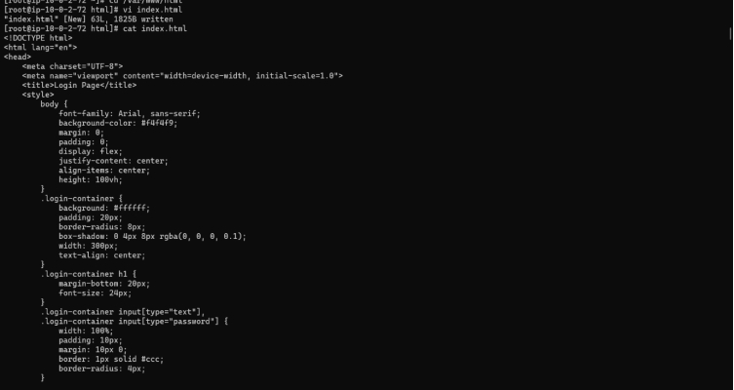

Final output

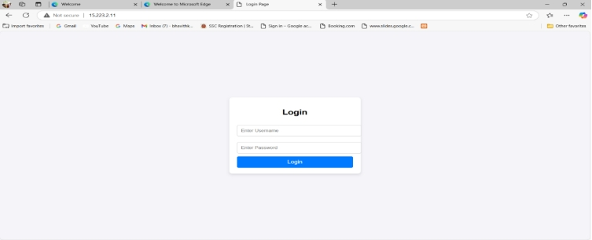

**MICRO-DEGREE INTERNSHIP**

**NAME:BHAVITH KUMAR B C**

**USN:4SN23MC009**

**Project-2**

**How to create new instances using amazon machine images**

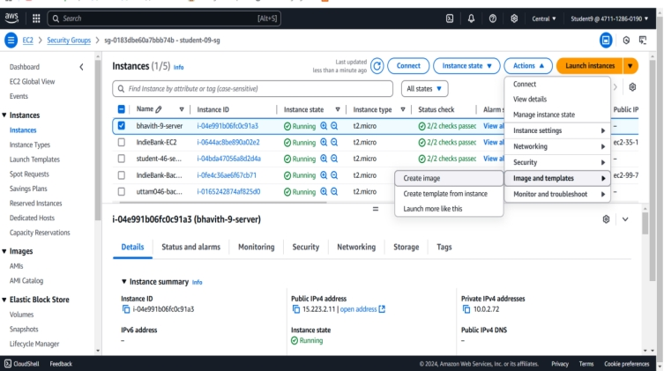

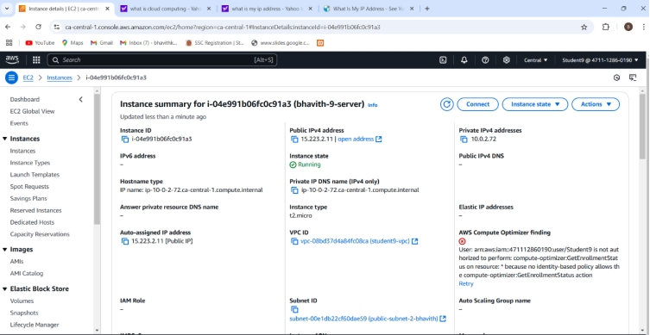

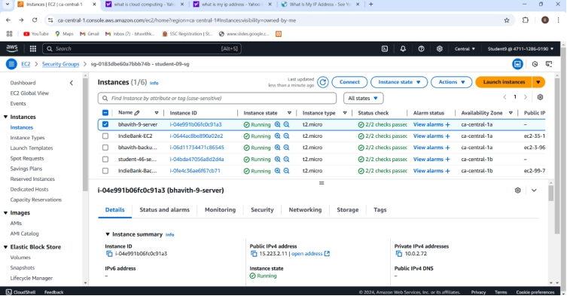

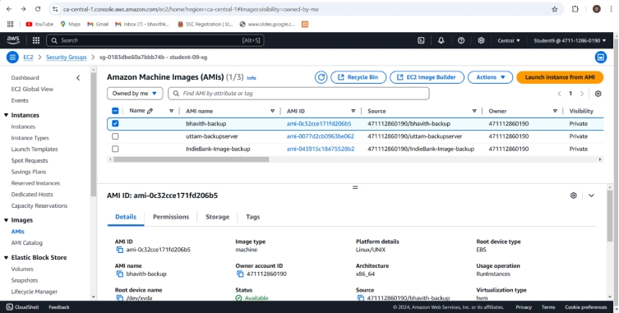

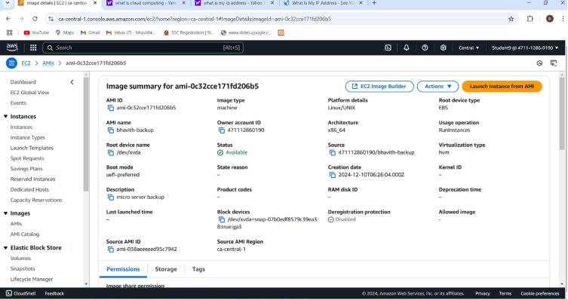

Final output

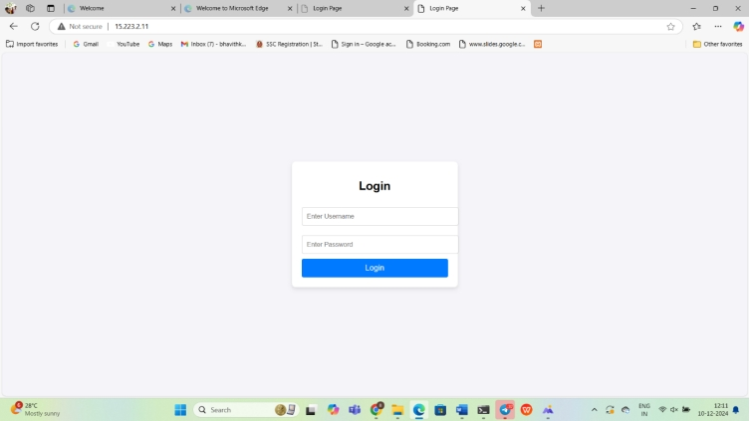

**MICRO-DEGREE INTERNSHIP**

**NAME:BHAVITH KUMAR B C**

**USN:4SN23MC009**

**Project-3**

**How to connect private server to the internet using NAT gateway:(Jup server/Bastion host)**



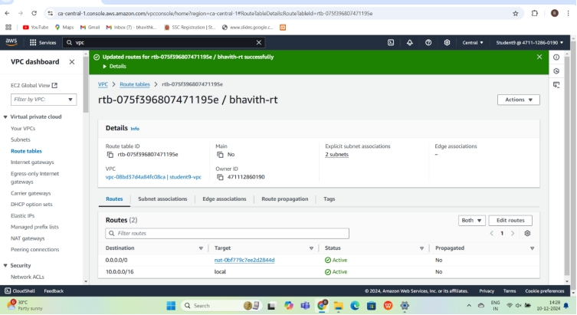

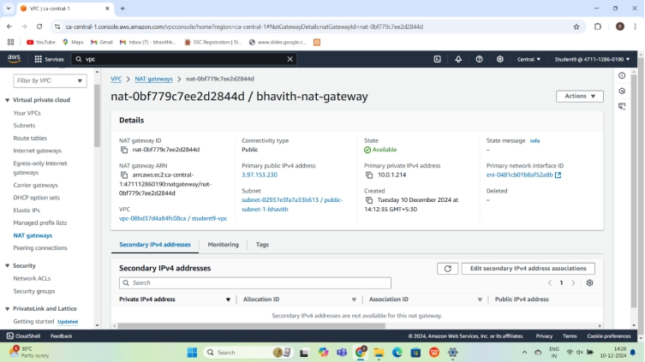

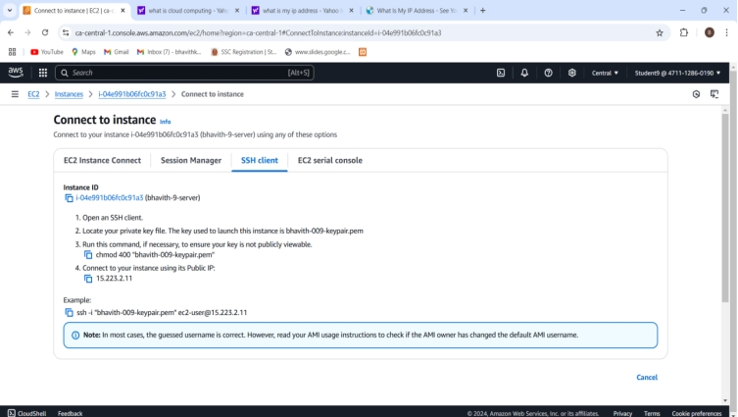

Final output

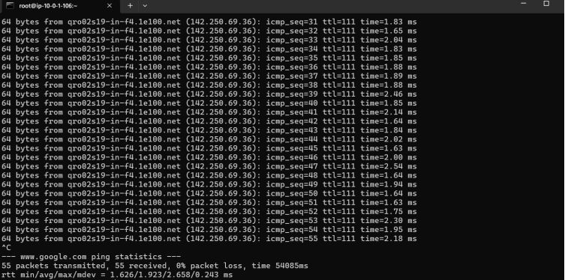

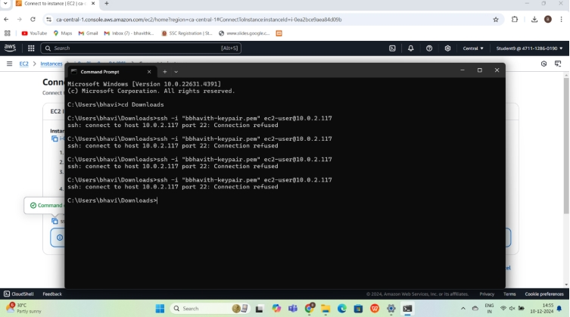

**MICRO-DEGREE INTERNSHIP**

NAME:BHAVITH KUMAR B C

USN:4SN23MC009

**Project-4**

**4.Hosting a static website using s3 Bucket**

**Create S3 BUCKET:**

**Bucket name should be unique**

**BUCKET NAME-bhavith2379**

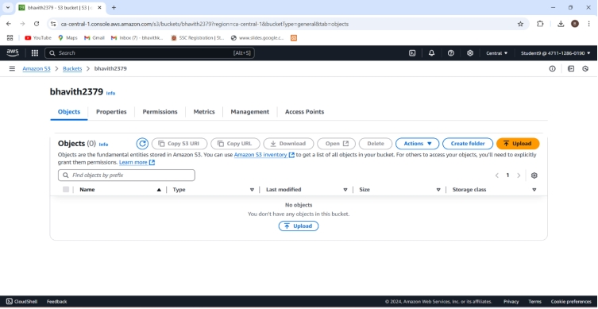

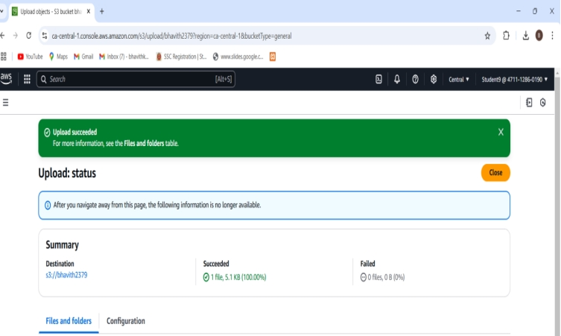

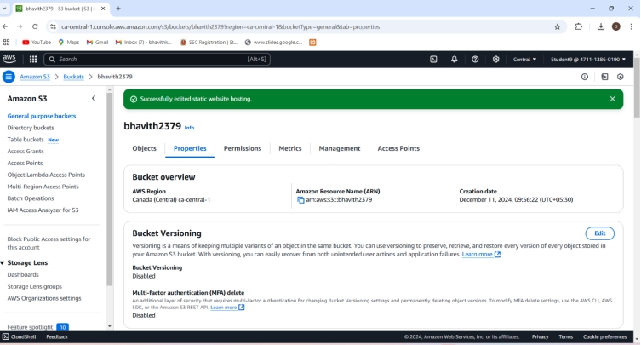

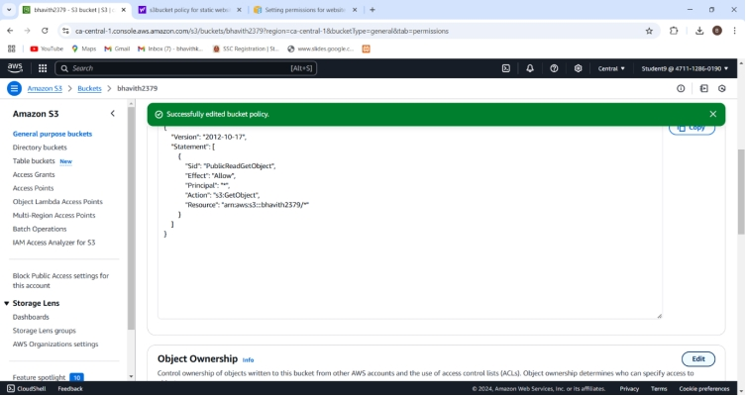

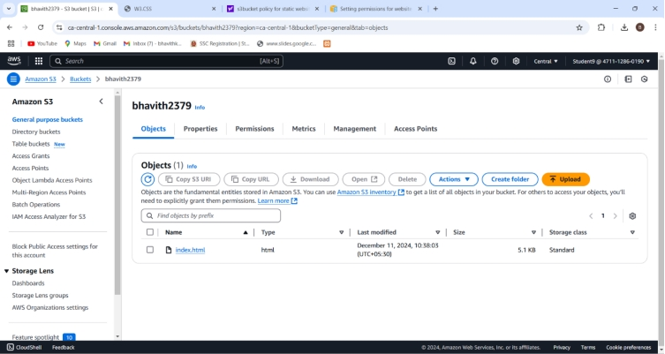

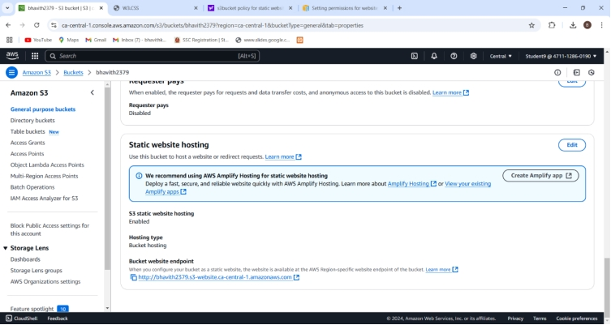

**Final output:**

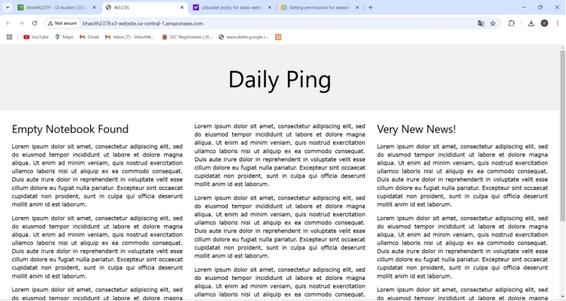

**MICRO-DEGREE INTERNSHIP**

NAME:BHAVITH KUMAR B C

USN:4SN23MC009

**Project-5**

lauching the website using load balancer DNS name:

Created vpc named bhavith09-vpc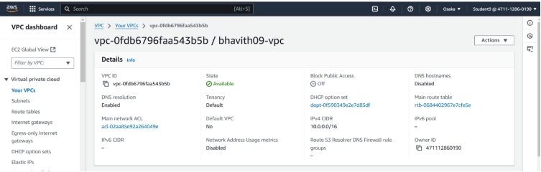INTERNET GATEWAY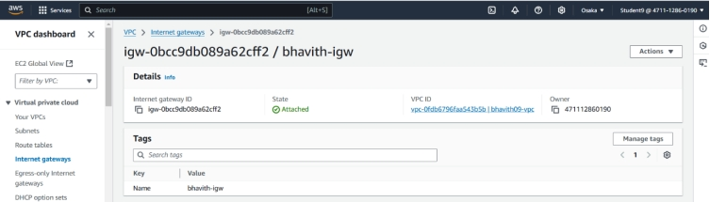PUBLIC SUBNET-1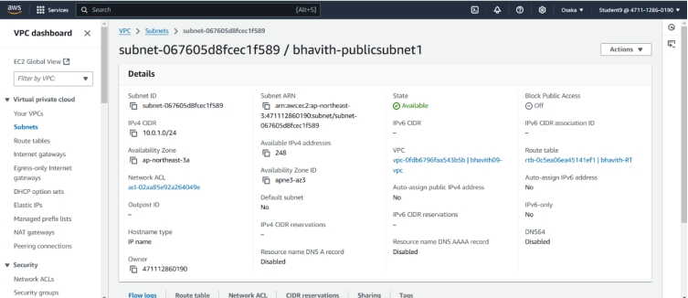

PUBLIC SUBNET-2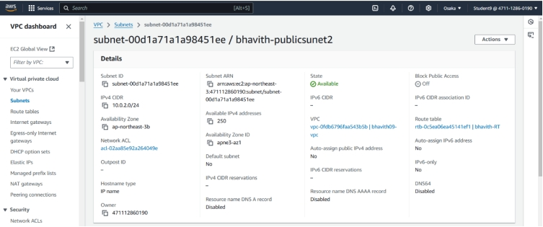PRIVATE SUBNET-1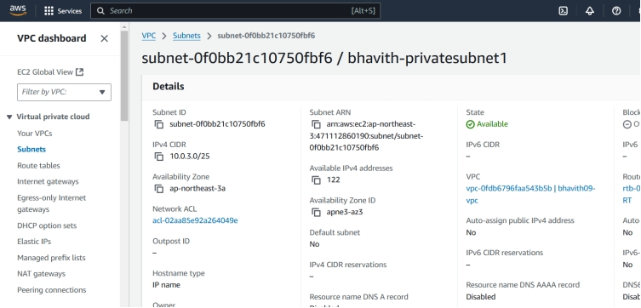PRIVATE SUBNET-2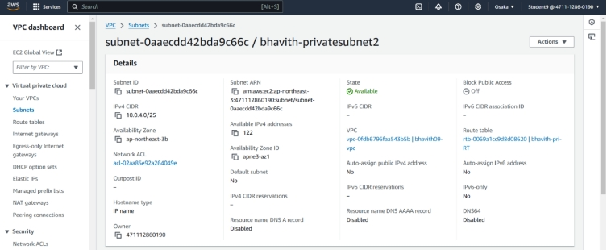

PUBLIC ROUTE TABLE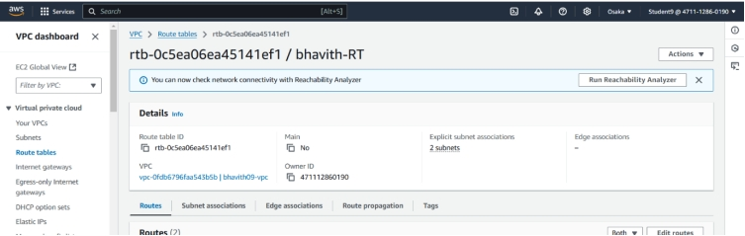PRIVATE ROUTE TABLE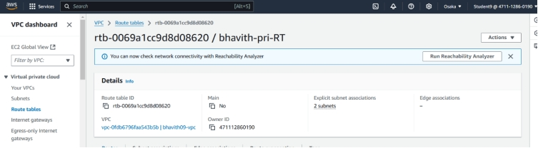NATGATEWAY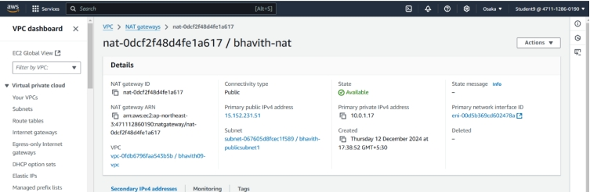JUMPSERVER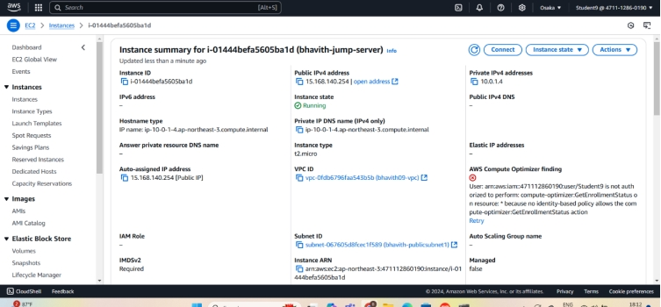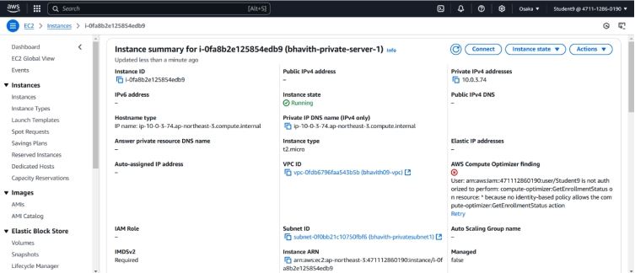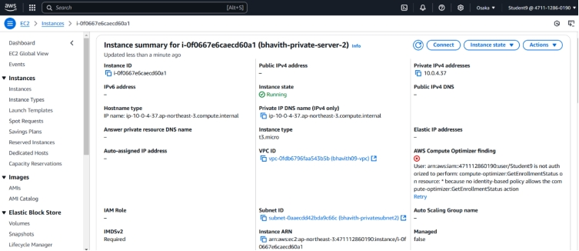TARGET GROUP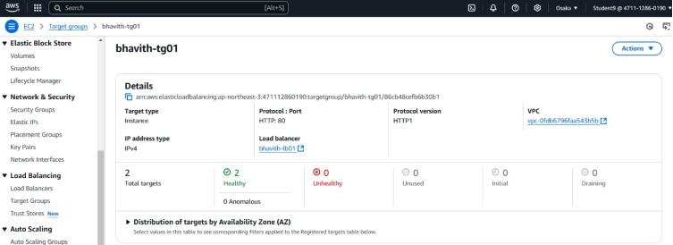

SECURITY GROUP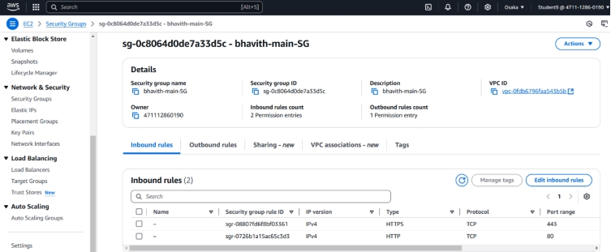COMMAND PROMPT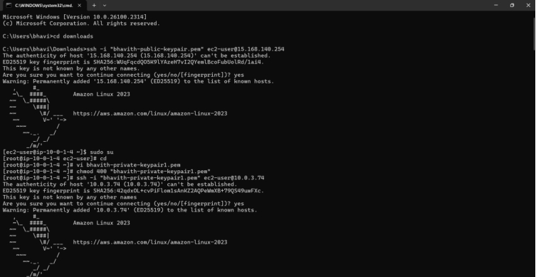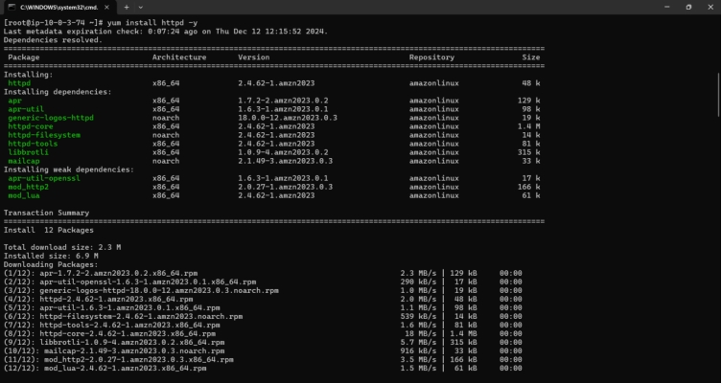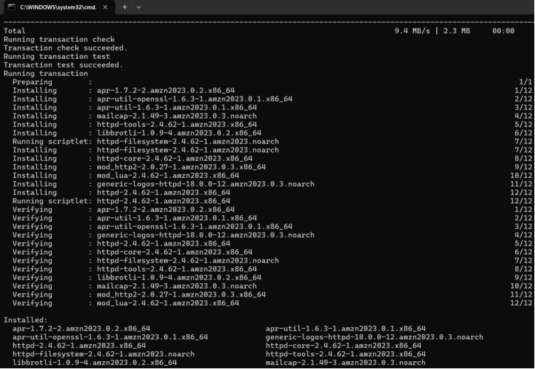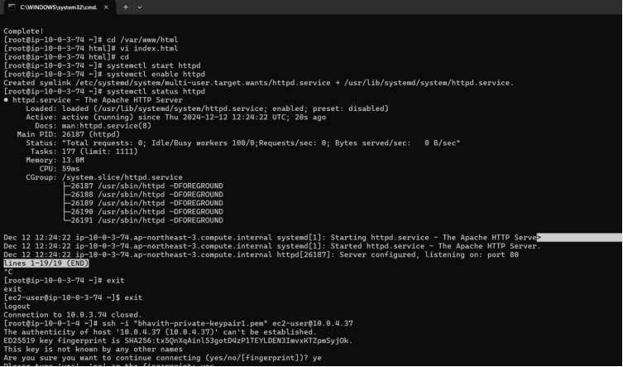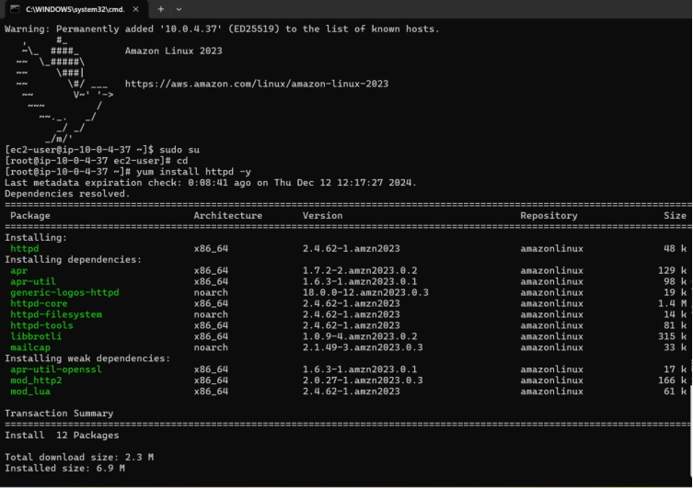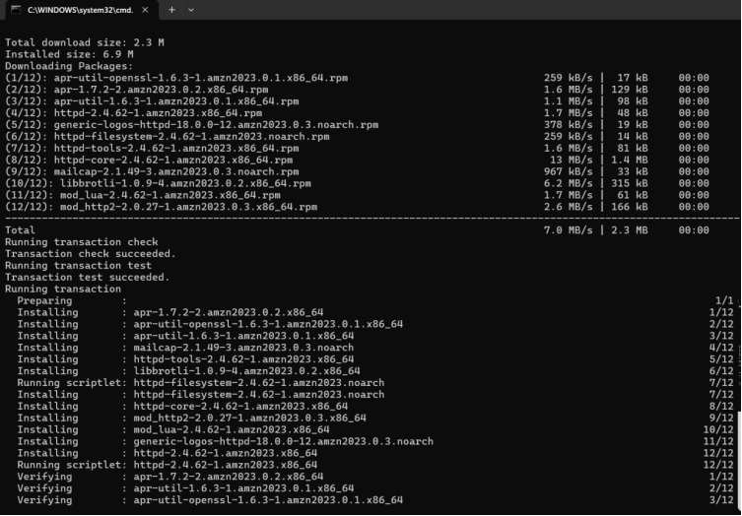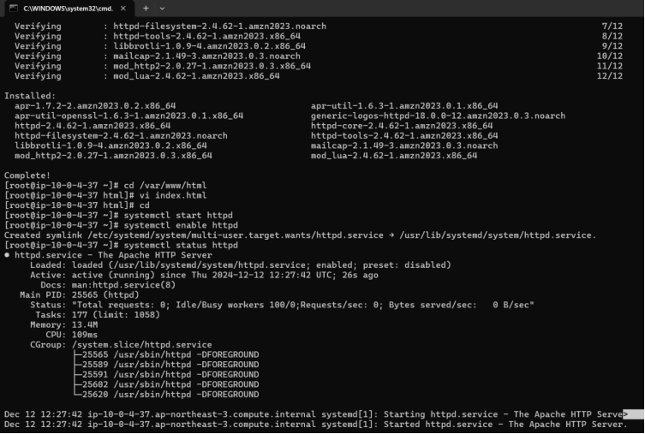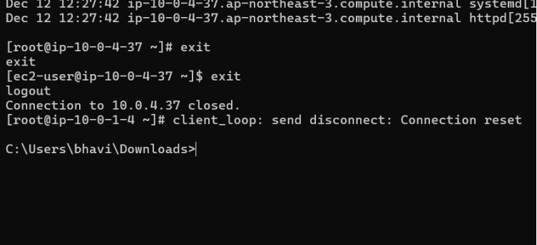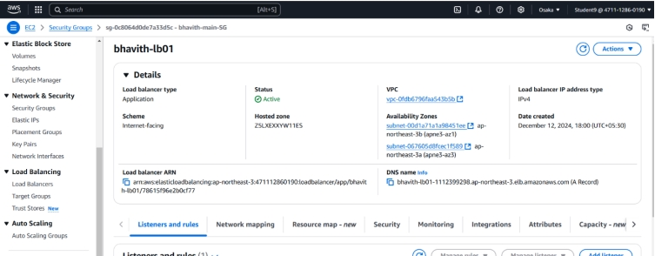OUTPUT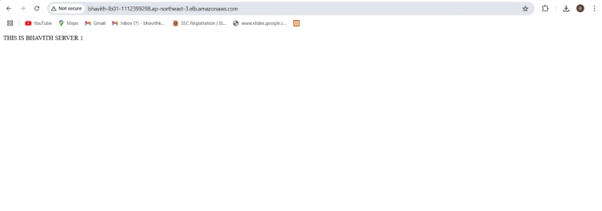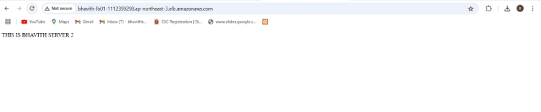

MICRO-DEGREE INTERNSHIP

NAME:BHAVTH KUMAR B C

USN:4SN23MC009

project-6 how to create repository in git hub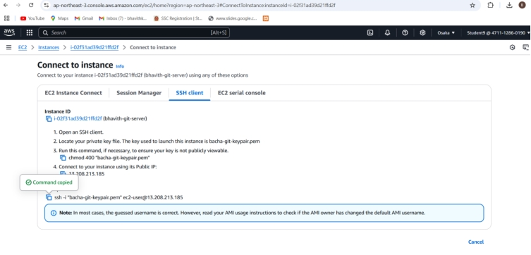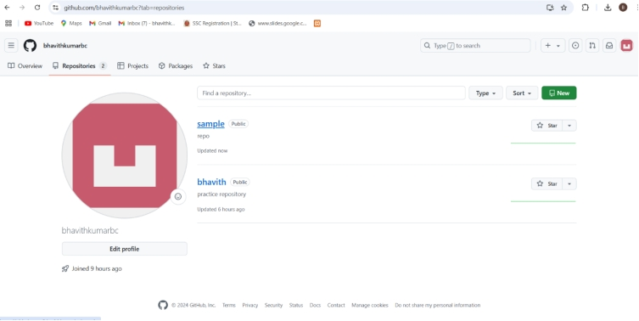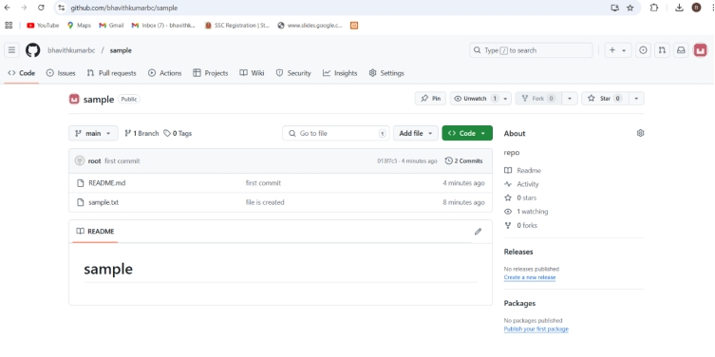COMMAND PROMPT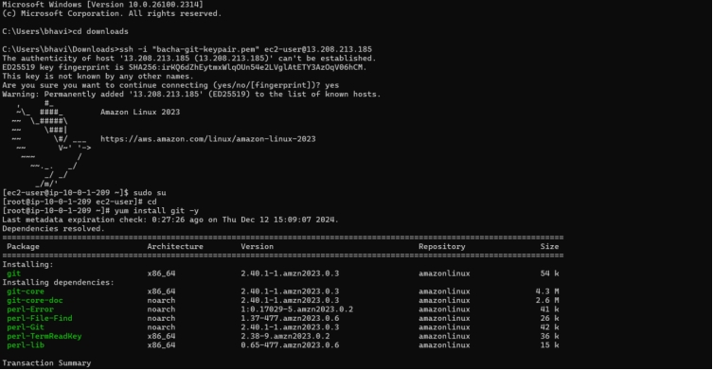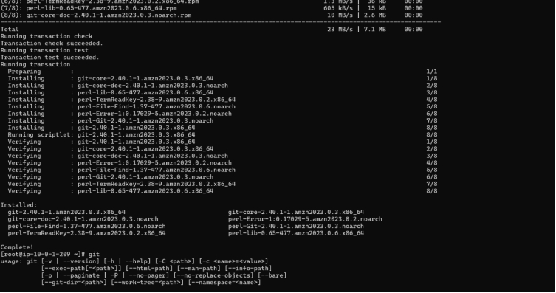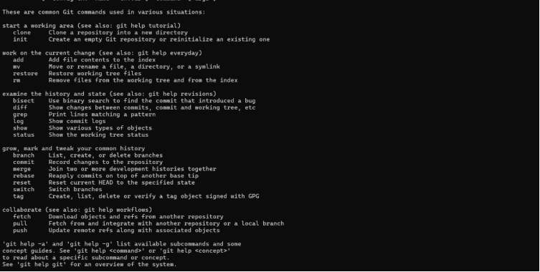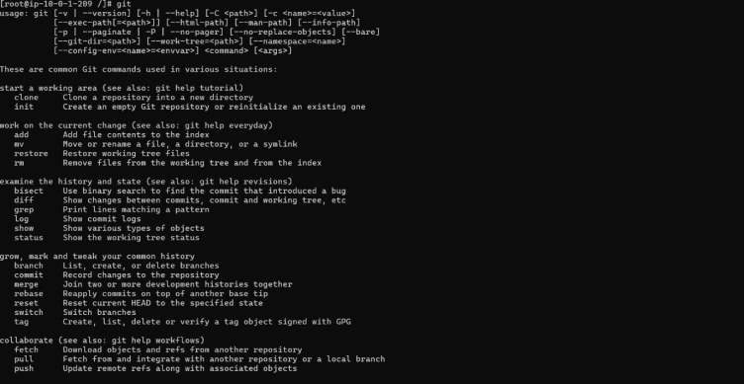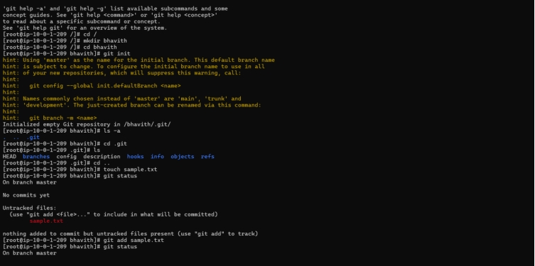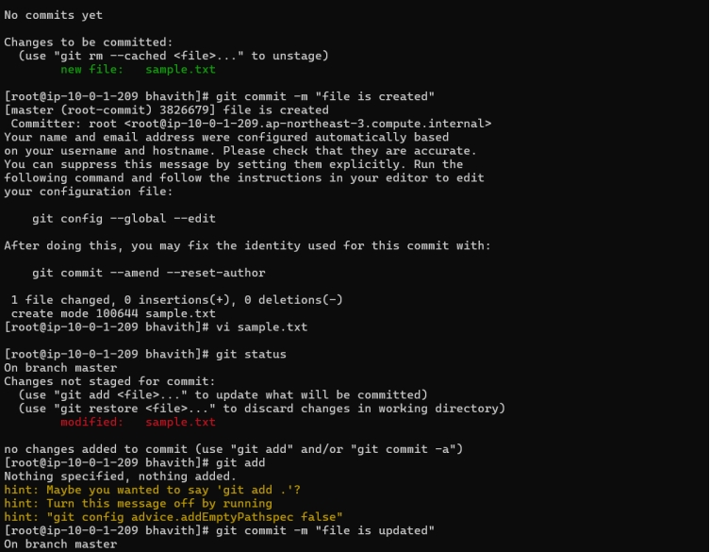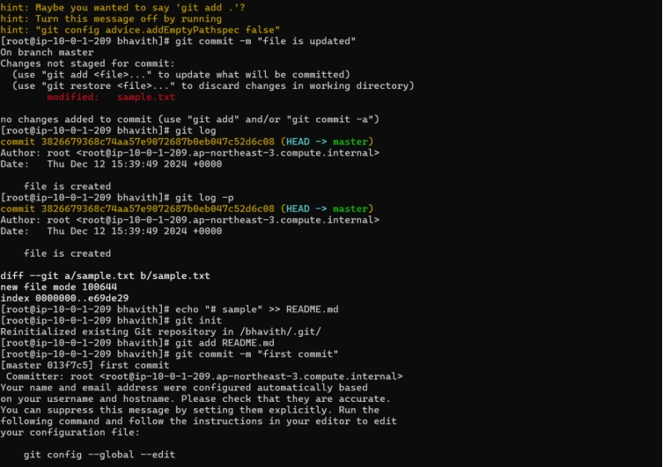

**MICRO-DEGREE INTERNSHIP**

**NAME:BHAVITH KUMAR B C**

**USN:4SN23MC009**

**Project-7**

**How to download and run project from git hub**

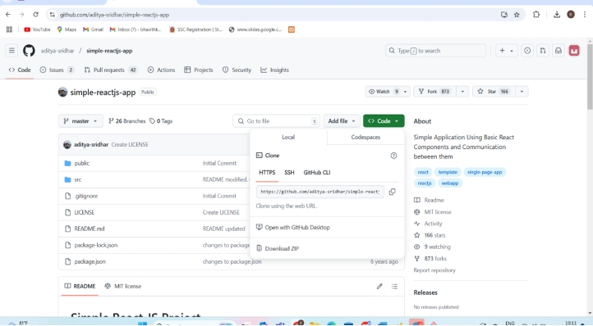

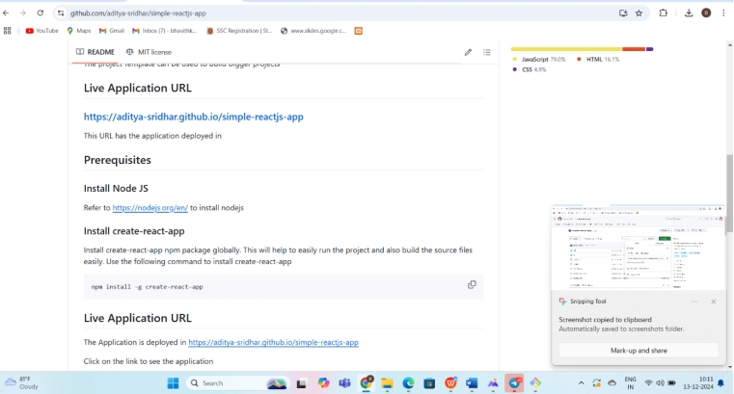

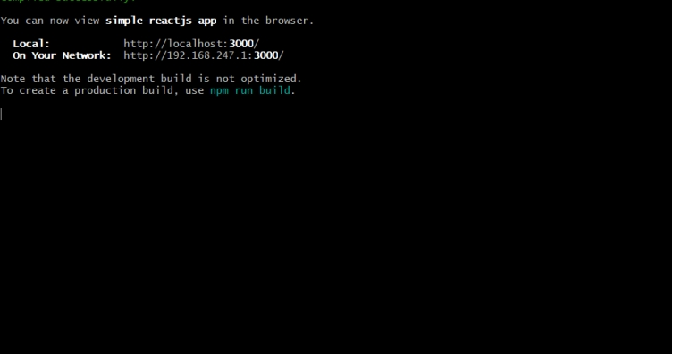

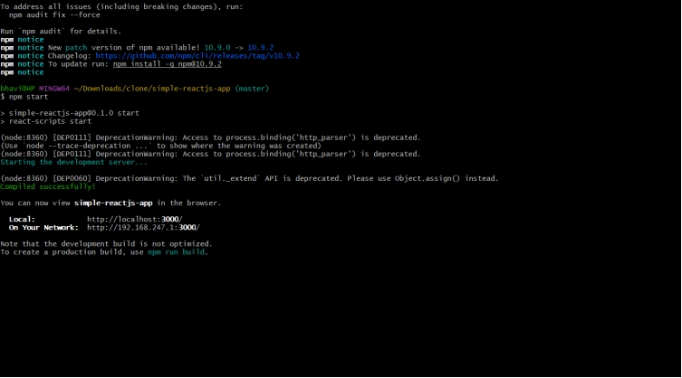

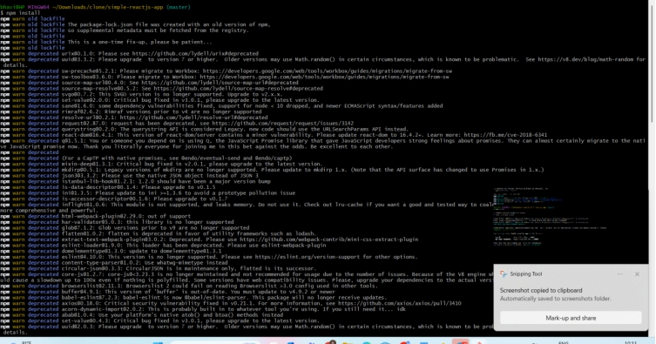

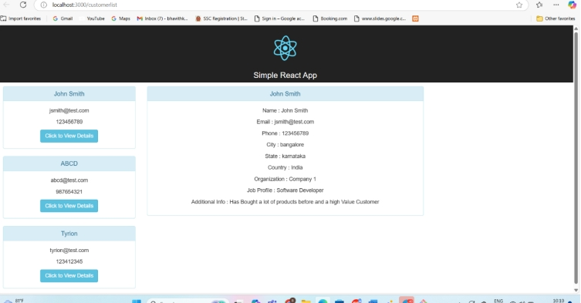

**MICRO-DEGREE INTERNSHIP**

**NAME:BHAVITH KUMAR B C**

**USN:4SN23MC009**

**Project-8-HOW TO CLONE GITHUB WITH JENKINS USING POLL SCM**

**JENKINS:ITEM NAME**

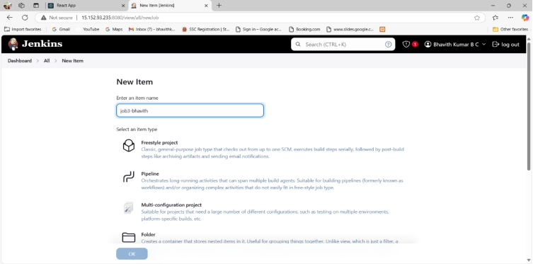

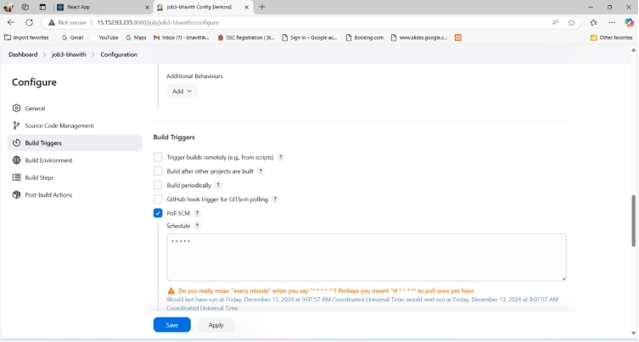

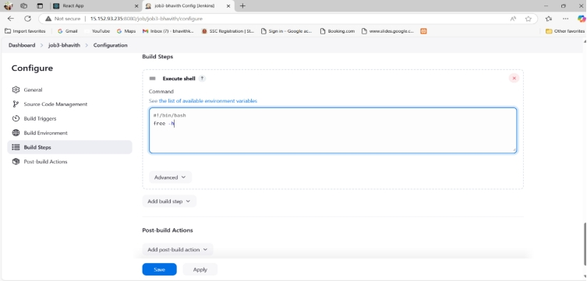

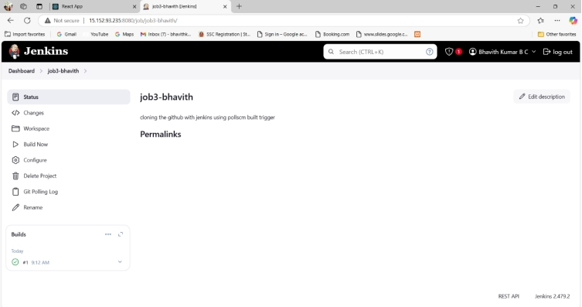

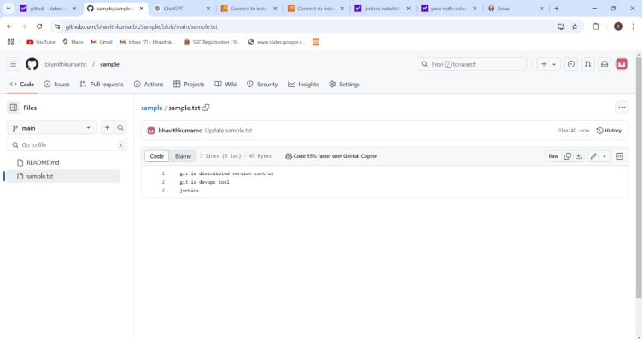

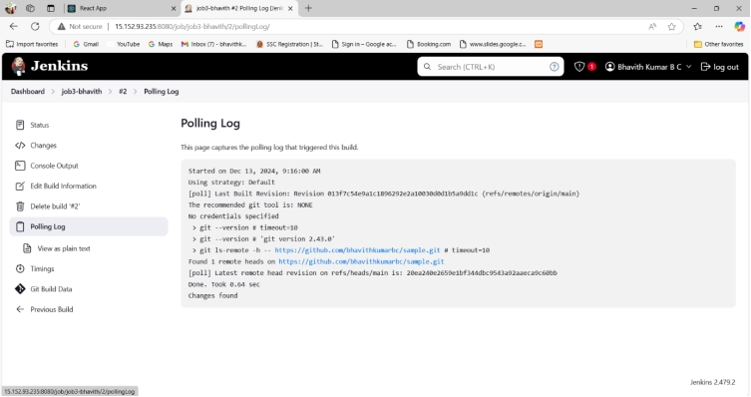

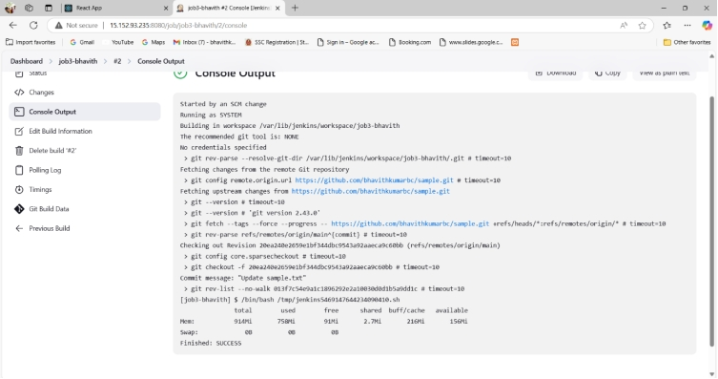

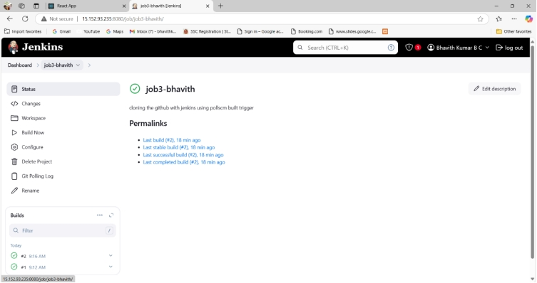

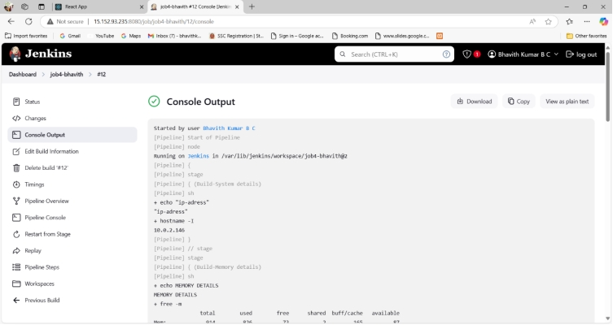

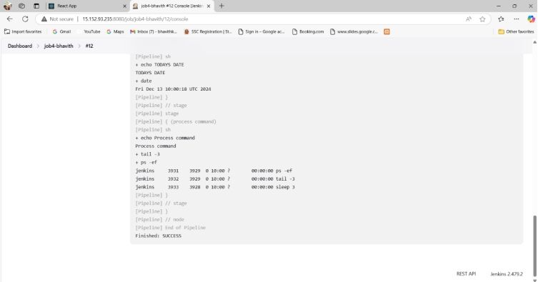

**MICRO-DEGREE INTERNSHIP**

NAME:BHAVITH KUMAR B C

USN:4SN23MC009

PROJECT-9HOW TO AUTOMATICALLY TRIGGER THE JOB IN THE JENKINS USING PIPELINE SCRIPT INTEGRATING WITH THE GITHUB

